Salford Creative Health Network Meeting  Weds 3 December, 11am to 1pm in Eccles  On Creative Health & Movement:  Geographical travel and physical activity | 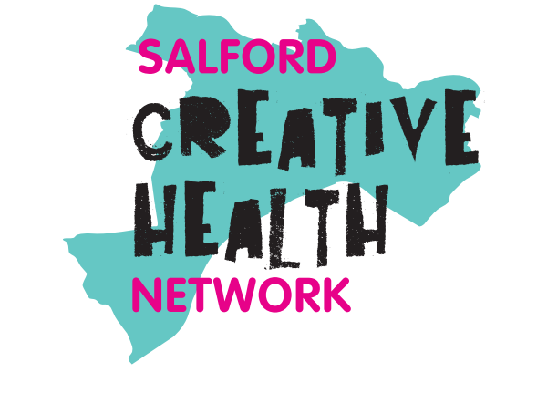
Welcome, housekeeping & intros
Nicola Swann, VCSE Strategic Lead in Mental Health and Wider Wellbeing
- Nicola thanked everyone for attending – and for a great turnout.
- Today’s theme & agenda has been led by the Creative Health Community Steering Group. Whenever you talk to anyone in Salford about barriers to accessing creativity & culture – travel and transport comes up.
- The first part of the meeting is looking at geographical movement – travel & transport.
- The second part of the meeting is looking at physical movement – the links between being creative, and being physically active.
- Nic shared that her role covers mental health, suicide prevention, nature for health, physical activity, creative health, and learning disability and autism. A priority is connecting these workstreams to create real impact. E.g. Physical activity, creativity, and nature can seem separate, but they are deeply linked. Each has proven benefits, and together they support prevention and recovery – someone living with chronic pain will inevitably feel the mental health impact.
- By integrating these offers, we can help Salford residents holistically, often in ways they don’t even see as “health,” putting them in a stronger position for wellbeing and resilience. However, great initiatives fail without clear communication with those delivering the work. Strategic decisions only succeed if frontline teams are engaged.
- Nic invited anyone with an interest in the above to drop her a line – to discuss how we bring strategic or top levels ideals & ambitions into practice at a grassroots & frontline level. Nicola.swann@salfordcvs.co.uk
Section 1: Creative Health & Movement – travel issues
- Nic invited Janet Charlesworth to share a personal experience of a travel issue in Salford impacting on access to culture & creativity as a starting point. Janet is an artist who lives in Walkden – who often has to travel to the Quays to access places like the Lowry.
- Aside from the time it takes to travel the distances involved – and the physical challenge of being a wheelchair user – what Janet found particularly difficult was the mental stress of knowing when/where she needed to change buses. On her first occasion as an independent traveller, she didn’t realise she had to move to a different bus stops across the street. In the end, Janet had to ring a friend for help. Beyond travel costs, there are layered issues here around physical access, complexity of routes, confusion and anxiety – which will hopefully be explored further in the discussion today.

Caroline used Mentimeter to gauge how people have travelled to the venue:
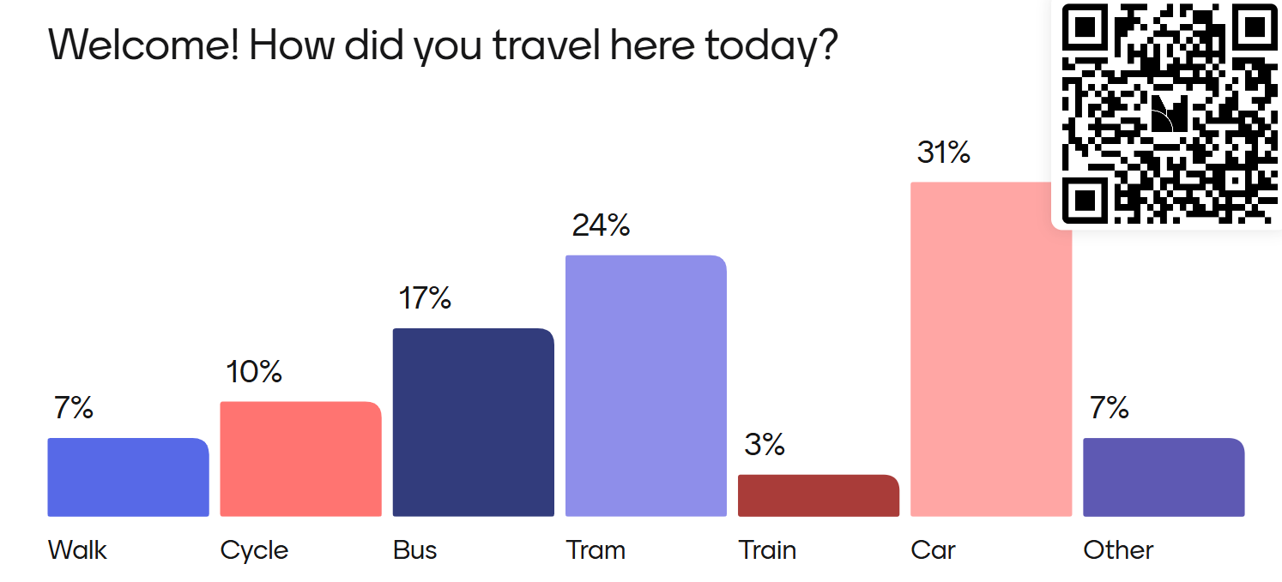
Sharing travel & transport support:
- When setting the agenda for today’s meeting – the Community Steering Committee were keen to have a representative from TfGM with us. Steve Burns has kindly joined us.

Steve Burns TravelSafe Prevention & Engagement Advisor at TfGM
- Steve shared strategic aims of the TravelSafe Partnership and talked about the work they do to make travel safer in Salford. This includes an HQ where TfGM can see where the hotspots are & respond. They encourage use of Live Chat for reporting.
- They also do community and education outreach – Crucial Crew at Y6. And reactive work in Secondary schools, PRU and Youth groups. This work has included the use of some creative techniques, e.g. the use of Virtual Reality headsets/experiences; producing a film on things thrown at buses; and campaigns covering what sexual harassment looks like/how to report/prevent.
- Questions from the floor included a note that Salford has good public transport routes into the city centre – but poor orbital ones. Changing buses etc can be confusing.

Andrew Fisher, Sustainable Transport Coordinator, Salford City Council
- Andrew Fisher shared insights on AttraActive Travel options in Salford. These included better design of streets to prioritise active travel; creative solutions to crossing the streets – such as colourful crossings or creative wayfinding; sustainable drainage; and creative design of public walkways to make them safer & more attractive. The challenge is how to make all the neighbourhoods of Salford more attractive for active travel. This could be as simple as painting metal cycle stands fun colours, or (where possible) re-design of road layouts to prioritise green space over road use.
- Questions from the floor included the observation that colourful crossings etc. might be attractive – but they need to be tested & checked by communities before being installed – particularly those with sensory of physical needs.
- It was also noted that active travel infrastructure is often good in central Salford – but places like Little Hulton are left behind. No colourful walkways or designated footpaths here. How do we spread these sort of creative attractive/active travel innovations around the city?
Creative project insights:
- Georgina Fox from 42nd Street/The Horsfall – told us about a project she is currently working on with the University of Manchester- using creativity to reduce travel anxiety in young people in GM. They have done things such as doing creative workshops on buses – with an aim to see how we can make transport more fun.
- GF also shared ideas around having a travel buddy system where young people might be able to use digital mapping to enable shared travel more? To take public transport together(or even a shared taxi) – rather than organisations pay for individual taxis which really adds up expense wise. And is more environmentally unsustainable.

- Astarte Cara from Walk the Plank shared info on a Salford 100 project which has transport & neighbourhood approach built into it from the first. WTP have recently taken a prototype wagon to 7 different locations in Salford to ask residents where it should go and what should be programmed on it. More info here www.walktheplank.co.uk/projects/salford-100/ This is a good model of taking creativity out and beyond the typical central Salford areas and into people’s neighbourhoods. How can more cultural venues/offers in Salford follow this model?
Table discussion: What are the key travel barriers to creativity in Salford?
Summary of key themes from group discussion:
Complexity / anxiety | Access – physical and sensory
- Poor/inconsistent travel information – particularly if coming in from areas such as Little Hulton, Walkden, Irlam and Cadishead.  - Confusing timetables / apps. Particularly if you have to change buses, or go between bus/tram/train.  - Anxiety re: if you will you know which stop to get off at? If not announced?  - Added anxiety if a service is running late. Can be left waiting and feel unsafe. | - Challenges for disabled users such as lack of audio announcements and limited accessible spaces on public transport. What to do if full?  - Lack of specific Salford support for SEND young people using public transport – build on TfGM videos but with Salford focus.  - The use of credit cards as default.  - Disabled people not consulted re design e.g. colourful crossing - RNIB highlight these as a problem.
Disconnection | Other
- Easier to get into Manchester than to go across Salford.  - Disconnection is an issue – Irlam to Broughton feels completely disconnected. | - Over use of taxis – e.g. for vulnerable groups to access creative venue – not sustainable cost-wise or environmentally.  - Reduced services on Sundays, inconsistency of services, or full/busy buses.  - Cost/time/safety etc.

Group vote: Each table/group voted on the biggest travel barrier using Mentimeter. Results: 1) Complexity; 2) access & safety. The room agreed that complexity is arguably the key issue where creative projects could be useful/address the issue.
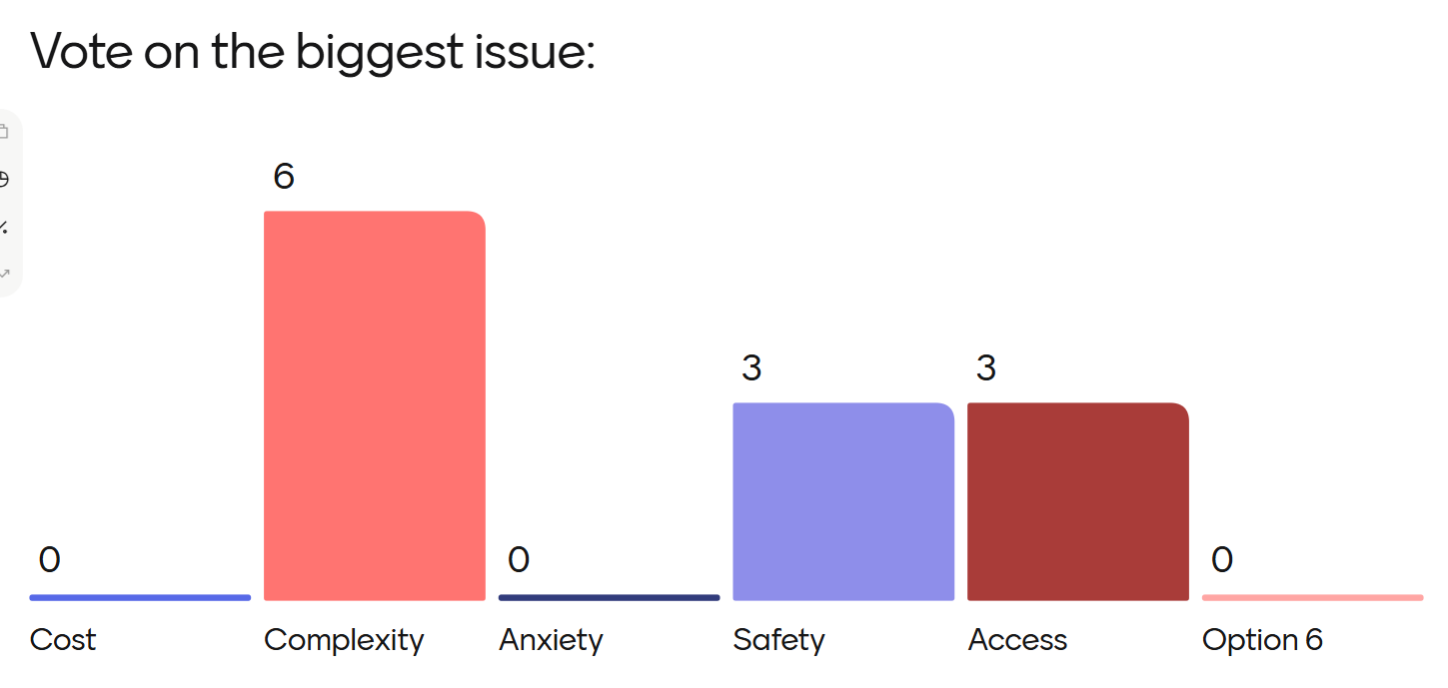
Table discussion: Are there creative solutions which could address these barriers?
Summary of key themes from group discussion:
Information / anxiety / | Access – physical and sensory
- Loads of opportunities for us to make travel more playful, fun and creative.  - Creative travel videos and info for outlying areas of Salford.  - Creative support to use Bee Network app to find info about support.  - Creative approaches to showcasing journeys and where barriers occur: let the system know where the pinch points are for different people  - Making travel fun, some kind of creative game to get to x amount of places in x amount of ways. Learn from Beat the Streets.  - Mapping young people's journeys to help plan new bus routes.  - Relationship between young people and place - dwell spaces, safe spaces, potentially interesting for child-friendly city work. | - More walking and wheeling audits to key creative/cultural venues in the city.  - An app to identify best route for those with mobility issues.  - Empathy training for transport staff. Need to make public transport ND friendly.  - Buddy schemes or peer support networks for those who need additional support.  - Need creative community engagement solutions around scheme design & public realm support – for active travel ideas.  - Illustrative maps, picturing landmarks as indicators of being on the right track. Including audio description of landmarks on particular routes.
Disconnection | Other
- It’s clear there are certain key areas – e.g. Walkden/Irlam – where people feel disconnected from cultural hotspots such as the Cresent & Media City.  - Could venues there collaborate with local people (and artists) to do some fun mini films that quickly showcase the route (including changes) so that anxiety about travel is reduced?  - Could they do downloadable guides or podcasts which might turn a long boring journey into some peaceful/inspiring time for the person? Pointing out local sights or stories; pointing out where to change; prompting simple activities; or just relaxation techniques. | - Be inspired by Beat the Street – incentives to get people to go to cultural/creative venues: Salford turns into a giant interactive game this autumn! Active travel.  - More escorted travel buddies. Community travel groups – like a walking group – but can go on an excursion together.  - Increase awareness of what’s already available – like the loopline.  - Rather than always thinking about the most direct route – are there more scenic/interesting routes that a creative project could bring out for local people. Or focusing on safe rather than most direct routes

Table discussion: If travel is tricky, how do we prioritise a neighbourhood approach?
- Some communities are very rooted in their area – and won’t leave. How do we connect, make most, support these local assets. But equally work on projects to connect to other areas. It’s a balance.
- Are Live Well representatives here today? Live Well might be an initiative which will help cultural organisations have a more neighbourhood approach.
- Some organisations are good at taking services/opportunities/activities out to communities in different areas of Salford. Others aren’t. Staff capacity is often an issue.
- We need better communication – a central place to find out what’s going on. Or a way for key organisations to be better networked so that opportunities can be shared/connected.
- How can we make local areas – e.g. bus stops a place where you might find a creative prompt/or signposting to creative/venues. Can we turn these boring places that we wait/waste time into something more creative, engaging or active?
Section 2: Creative Health & Movement – physical activity links. Project insights:
Morag Rose, University of Liverpool: #WalkCreate – insights into creative walking
- Morag shared that is a Walking Artist, Activist, Author and Researcher. Works at the University of Liverpool – but lives in Cadishead.
- When she uses the term ‘walking’ this very much includes wheeling – and she recognises that we all have different physical & sensory needs. And that not all needs are visible.
- During Covid, she created #WalkCreate Walking Publics/Walking Art - which developed into a book you can download here: www.walkcreate.gla.ac.uk . Email Morag if you would like a copy of the book posted to you: mlrose@liverpool.ac.uk
- Morag is interested in creative walking - activities that people undertake whilst walking which have an imaginative, playful, or task-based framework. These frameworks add an additional layer or lens of attention to the walking activity, giving it a particular direction and focus. This could involve: Treasure Trails: Following a 'thing': including art trails and treasure hunts; DIY Walking Art and Walking as Inspiration: making art or making up a game;Maps, minds and senses: Following an unusual, creative or artistic map, sound walks or an improvised challenge; or Digital communal games: Pokemon Go, geo-caching and using technology to walk remotely with distant friends.
- Morag stressed that WALKING + CREATIVITY = POWERFUL MAGIC. It’s a way to connect to your community; find solace in nature and imagination; and it improves mental and physical wellbeing.
- Morag recognised challenges to walking: e.g. bad weather; feeling that you have nowhere to walk; bored of walking the same route, etc. But is interested in how creativity can address these issues. For more info see Insta @moragloiters / www.thelrm.org
- Questions – very powerful to hear the connection that being physical & creative at the same time is powerful magic. How can we do this more in Salford?
Karl Chisipochinyi, Rachel Shenton, Community Navigators, Salford CVS
Family need in Salford and dance as physicality and creativity combined
- Rachel shared that she and Karl now work as Community Navigators – but previously with a focus on families and working with the Family Hubs. One of the key activities that Karl and Rachel referred families to was SCLs dance classes.
- They don’t have visibility on impact, or longer-term feedback after cases close. Can only speak to the families we’ve supported directly and the outcomes we’re aware of - but families often looking for activities that take kids off a screen – and that expend lots of energy in a fun way. The expressive energetic qualities of dance is the opposite of screentime. Which is passive and often solitary/low energy.
- Karl pointed out that for many parents/carers – going to the dance class is a chance for them to get out the house. They might be social/meet other parents, or it might be their only time to ‘disconnect’ and decompress. A dance lesson is effectively time for themselves – with their children looked after & active for 30/45 mins. Can then reconnect as a family both in a better mood.
Louise Seddon, Dance Development Officer for Salford Community Leisure
- Louise shared that SCL offers a range of dance activities for all ages & abilities. Some classes start at 2.5 years – children can have a very long journey with SCL.
- Can take exams and progress: https://salfordcommunityleisure.co.uk/dance-ivy-rose-story/. Can also find employment with SCL: https://salfordcommunityleisure.co.uk/scl-dancers-become-teachers/
- Beyond developing dance skills – dance is about wider benefits: improving self-confidence and esteem, making friends, developing social networks and opportunities to express yourself creatively in a safe and supportive environment. Creating special memories, and personal triumphs – e.g. someone doing a performance they/their families didn’t think you’d be able to do.
- SCL’s also offers dance classes for young people with SEND. And adult classes for those with medical or health conditions including seated dance classes for people with Multiple Sclerosis and dance classes for people rehabilitating from cancer: Dance for Everyone: How Salford Community Leisure is Making Movement Accessible to All – SCL and https://www.facebook.com/share/r/17hQYA5qsy/?mibextid=wwXIfr

How can Move More Salford & Creative Health Network work together?
- The discussion was started off by Caroline (from the Salford Creative Health Network) and Peter Locke (from Move More Salford). Caroline and Peter noted that physical activity (PA) & creative activity (CA) are often seen as different things/separate spheres. E.g. PA to do with health sciences, sports, and medicine, while CA with arts, culture. Distinct frameworks, professional groups & funding streams. PA is thought of as body work. CA as mind work. BUT we know that this isn’t true.
- Watching a clip of this video for Move More Salford it is possible to substitute the words ‘physical activity’ for ‘creative activity’ and the two networks have exactly the same mission: To inspire activity; find out what this means to people; make the most of local assets & contribute to healthier, happier Salford. Why do we work separately?
- https://www.salford.gov.uk/your-council/council-departments/adult-social-care-and-health-partnerships/public-health/moving-in-salford/move-more-salford/
- Peter acknowledged that although we often work separately – today is a chance to do more crossovers and keeping this going in the future. Going back to what Nicola said – and the need for a holistic approach. Is there a Salford model of supporting this type of activity which which brings sports, culture & nature together more.
- The holy grail are projects which bring it all together: art meets movement, meets green space, meets travel, meets connection.
- Caroline shared the example of One Green Mile in Mumbai. https://www.mvrdv.com/projects/787/one-green-mile Linear park built under a huge motorway flyover. Connecting neglected spaces beneath. Way to walk and connect. A series of rooms with creative interventions, aim to increase physical activity but also community connection.
Next Steps
- Notes to be shared. And will look for future opportunities to bring Move More Salford & Creative Health Network together.
- The next meeting will be end of Feb/early March 2026 in Broughton area.
- The theme is like to be: Is Creativity actually a bit scary? It’s easy to say being creative is ‘good for you’ but loads of us feel really vulnerable if asked to draw a picture, dance or sing – without the right creative conditions/support being provided. Lots of us were told we were ‘no good at art’ at school. Being creative can make you feel anxious. Why and when does this happen? What can we learn from professional artists and creatives about how they kept being creative going into adult life?
- If you don’t want to be included in any photos of the event please tell Caroline within the week. Any new attendees will be added to the mailing list.
- Caroline and Nicola thanked everyone for attending today. Particular thanks to Peter, Vania and Pamela from ECHO for their amazing hospitality & support today.

