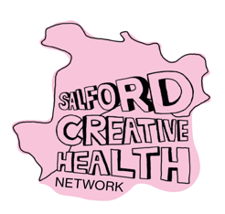 | 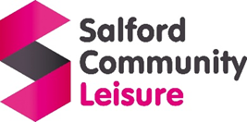
Salford Creative Health Network

In Spring 2026 we are running a social media campaign asking everyone to show us what Salford does to be creative – and how it makes everyone feel.
Everyone living, earning or learning in Salford is welcome to join in. Maybe you take your kids to a pre-school art class … or maybe you go to an older adults choir (and everything in between). Maybe you are a professional artist … or maybe it’s something you do to chill out when you’re not working.
You can share your pictures and stories as a group or as an individual. To join in, please:
- Send us a photo showing us what you do – whether it’s singing or sketching, nail art or needlework.
- Tell us in a sentence or two how it makes you feel.
You can tag us on social media @SalfordCreativeHealth on Facebook & Instagram, or email us on salfordcreativehealth@scll.co.uk. You can drop any questions to this email address too.
The stories and images that you share will give us a better picture of what local people do to get creative – and they language they use to describe the benefits. These insights will help to shape future community plans for creativity and wellbeing in Salford.
- We will not use any of the images you share without first seeking your permission.
- By emailing us or tagging Salford Creative Health we might message you back to follow up – asking a few questions and maybe seeking permissions as required – checking with you first.

