Salford Creative Health Network Meeting  Thurs 18 June from 11-1pm  Salford Student Union  NOTES | 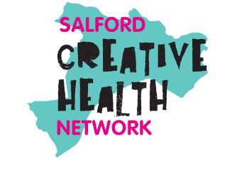
- Welcome: Caroline Alexander, Salford Community Leisure
- Caroline welcomed everyone – with special thanks to Emily & Matthew from Salford Student Union for hosting us today and helping with practical details.
- The aim of today’s meeting is to workshop the community feedback we have received on the Salford Creative Health Action Plan.
- Over the last few months, 7 community groups in Salford have been exploring what creativity means to them and how it improves their health. They’ve told us what they think the key barriers and opportunities are in the city. The Steering Group has reviewed all the community feedback – and our suggestion is that the best way to present these findings is as a zine.
- Zines are self-published, mini magazines that explore a subject someone feels passionately about. (The word comes from fanzine.) Zines have a DIY character that seems to reflect Salford’s personality – e.g. the city has 2 zine libraries/collections.
- Today we want everyone to tell us a) your response to the community feedback and b) what you think the zine should look like that conveys this info. What should the vibe/visual character be? What should the balance be between text & image? What’s a good title for our work? Which images/quotes/feedback from all the community sessions really speak to you. What is missing? What bits of the community feedback do we prioritise over others (given space limitations)?
- The plan is to use everyone’s zines and feedback in pulling the final Action Plan/zine together (with a better title). This will be developed by an artist for publication over the summer. Then, in the spirit of zines, we’ll print out loads of copies and distribute them everywhere from townhall boardrooms to libraries, GP waiting rooms, community centres and cafes.
- Alexandra Mitchell and Reis Tobolski have kindly brought some examples from zines from the University’s collection for us to be inspired by today. And Fiona Robinson a local artist and photographer is going to lead the creative side of the session.

- Update on the community consultation
- Caroline quickly gave a recap on how the need for a Salford Creative Health Action Plan developed. In 2024, when the Network first started meeting regularly, there was an awareness in that GM had published its Creative Health Strategy – and we needed to figure out how we put that top-level vision into practice in Salford. BUT we also needed to make sure our plans reflected what local people want. How does GM’s strategic vision connect up what people actually want in Salford – what the needs/issues/opportunities are on the ground here? At a Network meeting in November 2024 (at Arts Let Loose in Swinton) we came up with a plan for how we should produce a Salford Creative Health Action Plan. You can see notes on the 12 values/principles that the Network set for this work here.
- In early 2025, we then applied for funding from the Booths Charity and the Salford Culture Place Partnership to put this work into action. The Creative Health Steering Group with its 4 new Community Representatives (who were appointed June 2025) came up for a plan on how to approach this. It was agreed that we would offer 8 x community groups the opportunity to develop this action plan with us. The call-out for applications went out in the summer of 2025. You can find more info on this opportunity here.
- The groups were asked to consult with their communities around the following questions:
- What does creativity, culture and heritage mean to you?
- How does creativity improve your wellbeing?
- What are the biggest barriers to creativity and wellbeing in Salford?
- What are the biggest opportunities?
- Aside from more funding and better transport, what are the top 3 things you want to see in Salford to help local people be more creatively active?

- In the end, 1 of the 8 groups who successfully applied to work with us on this project dropped out (due to unavoidable reasons) so the 7 x community groups who worked with us were:

- 42nd Street working with Salford Youth Service in Walkden and using visual arts and creative map-making with young people
- Binoh of Manchester working at Hershel Weiss Family Hub in Broughton and using story writing, journalism and drama techniques to work with residents of all ages
- Humbug Art working with older adults in Eccles town centre and producing collaborative banners.
- Little Stars Swinton based at the Agnes Hopkins Centre in Swinton using music to work with families of children aged under 5.
- Salford Community Upskilling working in Pendelton and Charlestown with refugee and asylum seekers creating textile art pieces.
- Stepping Stones working in Princes Park Gardens in Irlam exploring being creative outside with people with additional needs and their families.
- Women with Wings working with global majority women in Little Hulton using henna, embroidery and calligraphy to explore identity and heritage.

- We used the underspend (from the group that didn’t go ahead) to fund an online social media campaign asking the widest range of community groups/people from across the city to respond to the same questions. You can find out more about that here.
- Caroline went through the community feedback – which is collated here. And showed a film which Tom Doona was commissioned to make about the process here.
- Having been given this context – the Network was invited to review the community feedback which was shared on each table. And a set of photographs linked to this work – and other key groups in Salford delivering creative health. Today is a chance for you all to review this information and consider how to creatively present it yourself – in designing a Creative Health zine for Salford based on these community findings/suggestions/actions. Before Fiona Robinson leads this creative session, Alexandra & Reis from Salford University Library are here to show us their best/favourite examples of zines in their collection.
Salford University’s Zine Library
- Alexandra & Reis kindly gave us an introduction to collection & showcase of zines. You can find more info on the history of the collection here.
- Alexandra noted that one of the reasons Salford Uni has a zine library is that it is an incredible way to expand the range of voices that are included in an academic library. For example, there will be countless medical/scientific books in the library bookstacks – but the zine collection enables the inclusion of lived experience voices about particular medical conditions – for example living with a catheter – alongside these more traditional/formal texts.
- Reis noted that zines started to be published from around the 1920s. They are often vehicles for expression – often for marginalised voices – where people can put down on paper their world view – even it if it outside the norms of the time. Often zines were deliberately used to counterbalance negative perceptions and/or to foster a sense of community amongst those who felt marginalised. E.g. the first LGBTQ+ zine published by Edith Eyde under the pseudonym Lisa Ben.
- Alexandra and Reis also noted that many zines often include creative activities within them – e.g. cut outs and prompts to use the zine for your own creative purposes and for the zines to have another life within them. They aren’t a finished product – but can have a creative prompt/process within them. They also noted that there is not one ‘perfect’/standard form for zines – that’s their selling point – they are totally flexible/adaptable to your purposes. They can be stapled booklets, or single folded sheets, in various sizes, with various mixtures of word and image and style/approach. Everyone was then invited to look at some examples from the collection here today as inspiration.
Creative Session – led by Fiona Robinson
- Fiona talked about a recent zine-making project that she worked on with Gaddum in Salford. As part of the Caregiving project, exhibited in Salford libraries, local carers used words and pictures to share their stories/experiences with local health and social care professionals to showcase the reality of caring for someone. Fiona has had personal experience of caring for her husband who lived with dementia – which she documented through photography – and she found this creative outlet a wonderful way to process the emotional impact of caregiving herself. She also works as a socially engaged photographer. And is Photographer in residence at RHS Bridgewater Wellbeing Garden in partnership with Open Eye Gallery and University of Salford Art Collection.
- For this session Fiona stressed that each table could take their own approach to folding and selecting the shape/format of the zine. She showed us a variety of fold options from simple to complex – but the traditional zine fold/format uses an A2 sheet with a hole cut in the central section – so that it can be folded into an 8 page booklet. This gives you different options for organising your content into themed pages. And there is also the option for one side of the folded page to be used as a single large ‘poster’ image. Each table was then invited to 1) review the findings of the community feedback and 2) organise this info into their own zine mixing word & image.
Group discussion/activity and feedback
Each group/table then created their zine – and were invited to talk through their thoughts.
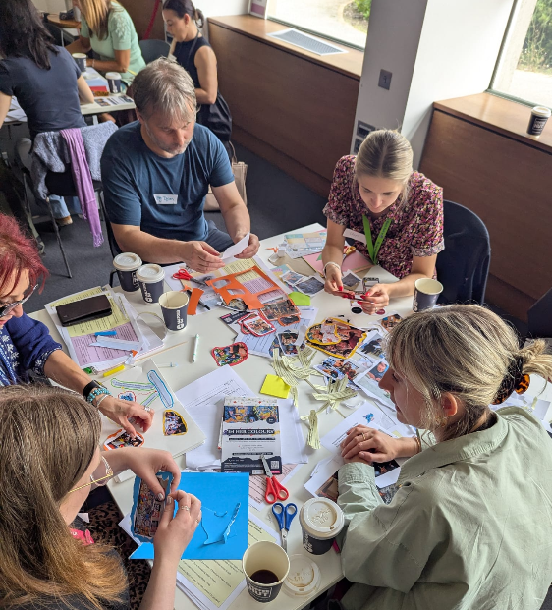 | 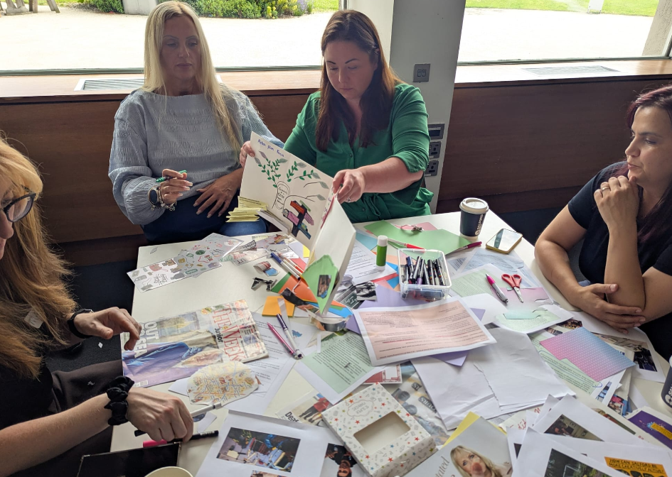
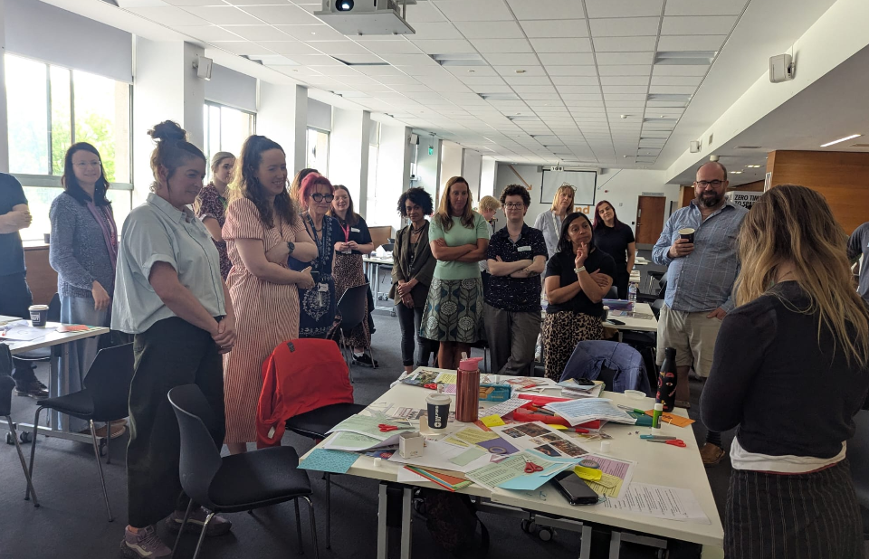 | 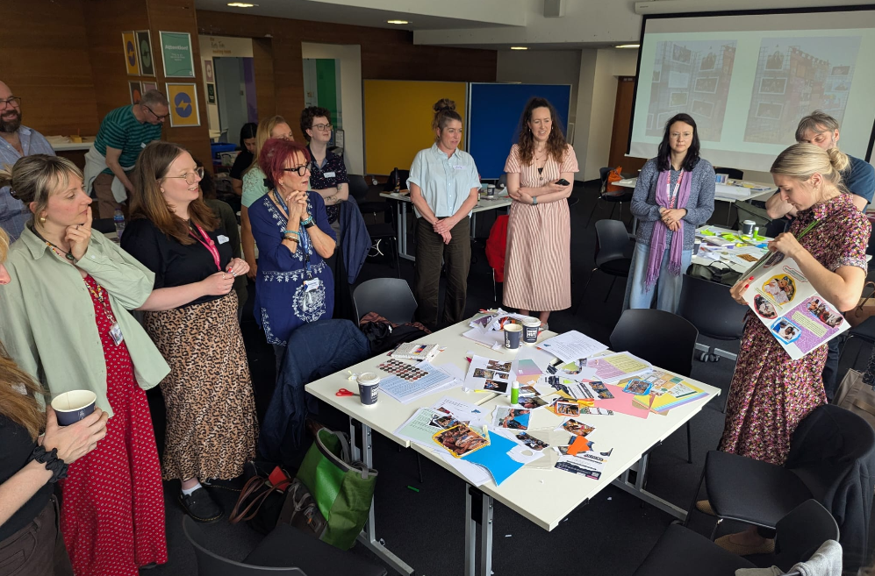

A summary of discussion is below – including a ‘brief’ we want to give the artist who designs the final zine:
Visual feedback:
- The document needs to be simple/easy to navigate but beautiful/interesting to hold/flick through.
- It has to look ‘Salford’ from the first – and all the way through. Through images/language/people/places/landmarks etc.
- There needs to be an emphasis on real life quotes and photos. All about creativity and community.
- Maps of Salford; pictures of places and people – it needs to look real/recognisably Salford.
- It needs to be artistic – not council/office looking.
- Cut edges, hand-drawn elements, collaborative in feel. The work of many hands – but simple/single vision.
- People showcased some amazing creative ideas – like pop-up, zines-within-zines, but there was also recognition that a simple central poster image – that summed everything up/brought everything together would be ideal. That might work as an artwork in itself.
- People liked the idea of a creative health activity/prompt embedded in the zine itself – the zine isn’t a finished product but something that’s a part of an on-going creative process.
- People like the tree motif. Roots/growth/branches. Salford means Willow by the Ford. Trees & rivers – great motifs. But balance that with Salford as a modern city today – with a long urban/changing history. Cobbles & high rises. Shopping City etc.
- Use the tree motif – creativity as a core health behaviour.
- Maybe have a timeline maybe – to show what we want to happen when?
- People liked Humbug Arts maps – that aren’t of a particular place. But are just generalised map motifs e.g. roads/lines of connection/with ideas/thoughts set within the spaces between. Salford is spread out city of many centres – but it is connected. That road/hub motif sort of brings that together. Maps are a great motif – but it doesn’t need to be too specific. E.g. not an exact map of Swinton. More about roads/rivers/hubs/locations/connections – heading in a direction.
- Can we use road sign motif to put the action points on? Direction of travel?
- Bees are a great motif – busy/flying through the sky. Hives/coming together/going to flowers/moving around the city. Clouds/the skyline – every changing. Roots/history.
- Using interesting shapes and colours – but keeping it simple. Can’t be too busy/confusing. But needs to look interesting/have useful content/info.
- Maybe tap into the palette of the new Salford Creatives website/branding – not to look the same/but aligned/in the same spirit. Maybe also Live Well colours.
- The vibe that you want to say about creativity – that it’s a process not product / that it’s about having a go not being good – that needs to be reflected in the style of the zine. It can’t look all perfect & professional – that isn’t what CH is about.
Content feedback:
- Hard balance between conveying relevant info/setting the scene/context (the past) but also what we want to do the (future plans). All whilst not being too wordy.
- The feedback that the groups have given is great. For the sake of this document – which doesn’t need to live forever – we just need to get going.
- We need to set the scene/context. Share what people have told us. Convert that into 4 actions for each of the strategic goals. Keep it light & doable. Things that are doable within the year.
- It needs to set out a clear goal / ambitions/ what we are going to do /have some actions that are measurable/completable. It needs to have a bit of strategic clarity. E.g. set out:
    - The vision – where we want to get to – the destination.
    - Our strategy – how will we get there.
    - The action plan – what will we do next.
- It also needs to give context to the why this has been produced. Set Salford in national/international/regional context – but do this quickly/light touch.
- How does it link to other initiatives – e.g. GM Creative Health Strategy or Live Well. It also needs to show a life-course focus – with a focus on work/activity linked to children, adults and older adults.
- It needs to be an invitation – open me. You are welcome. Speak to ‘you’ make it relevant/personal to people. Connect with people from the front page. You are an artist or something.
- Needs a great title. Draft ideas for titles:
    - Creative Health: The Salford Way
    - Salford: Your Creative Health City
    - Salford Creative Health City
- We are a Network – not a provider – we’re not about delivery. We’re about bringing people together, connecting, signposting, celebrating, supporting the providers in the city. Need to make that clear.
Close of meeting & next steps
New Steering Group membership/composition:
The structure of the Steering Group is going to adapt slightly in this coming year into 2027. Standing members of the Group will now include:
- Salford City Council Public Health – Nicola Prescott
- Salford Community Leisure – Caroline Alexander
- Salford CVS – Nicola Swann & Bev Fletcher (Vocal Lead)
- START Inspiring Lives – Maggie Lister
- Arts for the Blues, University of Salford – Scott Thurston &/or Joanna Omylinska-Thurston
We are also seeking to appoint 4 x Community Representatives – who will be paid for their time to attend meetings. (Membership of the Steering Group is for 1 year from approx. July 2026 to July 2027.) Selection will be on the basis that the new Steering Group best reflects a) the geographical range of the city; and b) different community groups by interest, identity, or age. At least 1 Community Representative role will be given to a young person aged 18-25.
Future meetings for 2026:
- October 2026 (date TBC but it will be at Pendleton Library community room) and it will be a creative mapping exercise. What does the Salford Creative Health ecosystem look like? Can we use this Bristol example as a starting point: https://www.carys-ink.com/project/bristol-creative-health-ecosystem/ We’ll get coloured paper & glue and map out the look and feel of Salford creative health ecosystem. We’ll work with an artist to facilitate the session overall. But we also want each table to have a creative lead & a system lead – please can we have any volunteers to take on these roles? Please email caroline.alexander@scll.co.uk to get more info.
- Dec 2026/Jan 2027 – planning event for the Creative Health Showcase we are planning for May 2027 – see below.
- May 2027 (date and location tbc). Major stakeholder event to tie in with Creativity & Wellbeing Week & Mental Health Awareness Week which both normally take place mid-May. We’ll aim to invite key health and city leaders to an event which showcases the key players & success stories in Salford Creative Health. And we’ll aim to plan this event in collaboration with e.g. the Director of Public Health in Salford – and invite key city/GM health contacts. At this meeting - can we give all the city leaders all the info they need to publish a Salford version of this Public Health Report. Or similar.
- May 2027 – Pop-up exhibition also to be organised to showcase Salford Creative Health – to be installed Unity House/Civic Centre for Creativity & Wellbeing Week. Local organisations invited to submit photos & quotes to showcase activity – and what people get out of it. Across the city/across age groups. Can be used again for World Mental Health Day in October 2027. Something akin to this which the Youth Service have done:
